**KEY PAD**

**GENERAL EXPLANATION:**

A group of keys in a single printed circuit board is call key pad. These key pads are classified into two types.

1. Key pad
2. Matrix keypad

**1. KEYPAD**

In a key pad it has a one or more then one keys are placed in a PCB. And all the keys are commonly grounded. This is the main difference to compared to matrix keypad. This key pads having maximum 8 numbers of keys. more then 8 keys are can not be connected because its not a efficient one. If we need more then 8 kays means, then only we can operate it a matrix keypad.

**2** **MATRIX KEYPAD:**

Above same keys are connected in a matrix principle it is called as a matrix key pad. This matrix key pad is working with the help of software. Otherwise it can not work. This key pad is normally 3X3, 4X3, 4X4 like that.

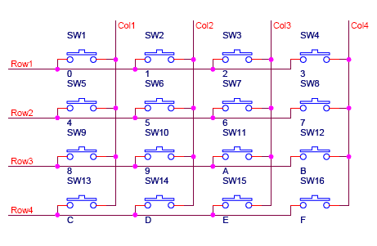

**SCHMATIC EXPLANATION:**

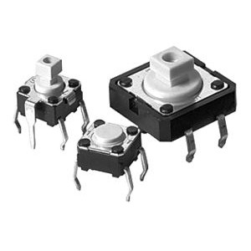  
 There are many methods depending on how you connect your keypad with your controller, but the basic logic is same. We make the columns as i/p and we drive the rows making them o/p, this whole procedure of reading the keyboard is called scanning. In order to detect which key is pressed from the matrix, we make row lines low one by one and read the columns. Lets say we first make Row1 low, then read the columns. If any of the key in row1 is pressed will make the corresponding column as low i.e. if second key is pressed in Row1, then column2 will give low. So we come to know that key 2 of Row1 is pressed. This is how scanning is done. So to scan the keypad completely, we need to make rows low one by one and read the columns. If any of the button is pressed in a row, it will take the corresponding column to a low state which tells us that a key is pressed in that row. If button 1 of a row is pressed then Column 1 will become low, if button 2 then column2 and so on...

**KEY :**

**KEY DIMENSSIONS:**

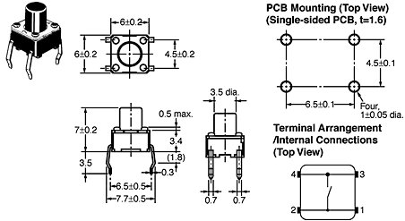

**PCB LAYOUT:**



**Item specifics**

Place of Origin:

Zhejiang China (Mainland)

Model Number:

KFC

Size:

12mm x 12mm x H6mm

Contact:

Metal contact

Rating:

50 mA x 12 V DC

Contact resistance:

100M ohm max

Proof voltage:

250 V AC for 1 min

Insulation resistance:

100M ohm min/100 V DC

Temperature:

-30~+70 Degrees

Quantity:

1000pcs/lot

Weight:

900g/lot

**APPLICATION:**

Basically key pad is a number of buttons compiled in such a manner so that forms formation of numeral button and some other menus. Following is example configuration of key pad. Keypad needed to interaction with system, for example we make setting with set-point would a control feedback at the time of program still run. Actually every programmer has different way interaction to with system. Even for keypad in hardware every programmer can differ in. This thing is more because of different requirement.